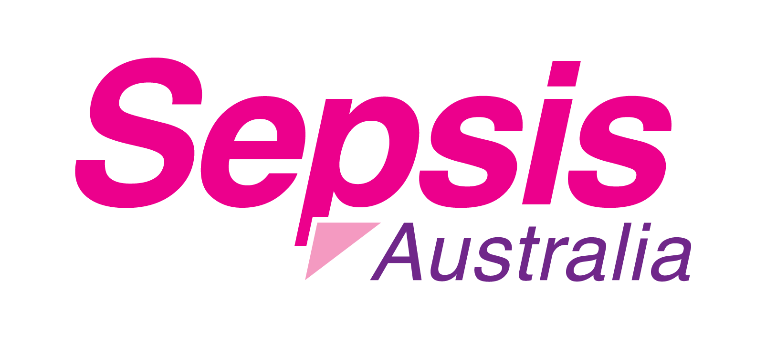
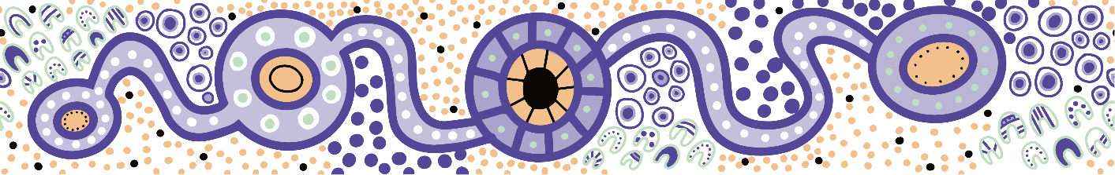

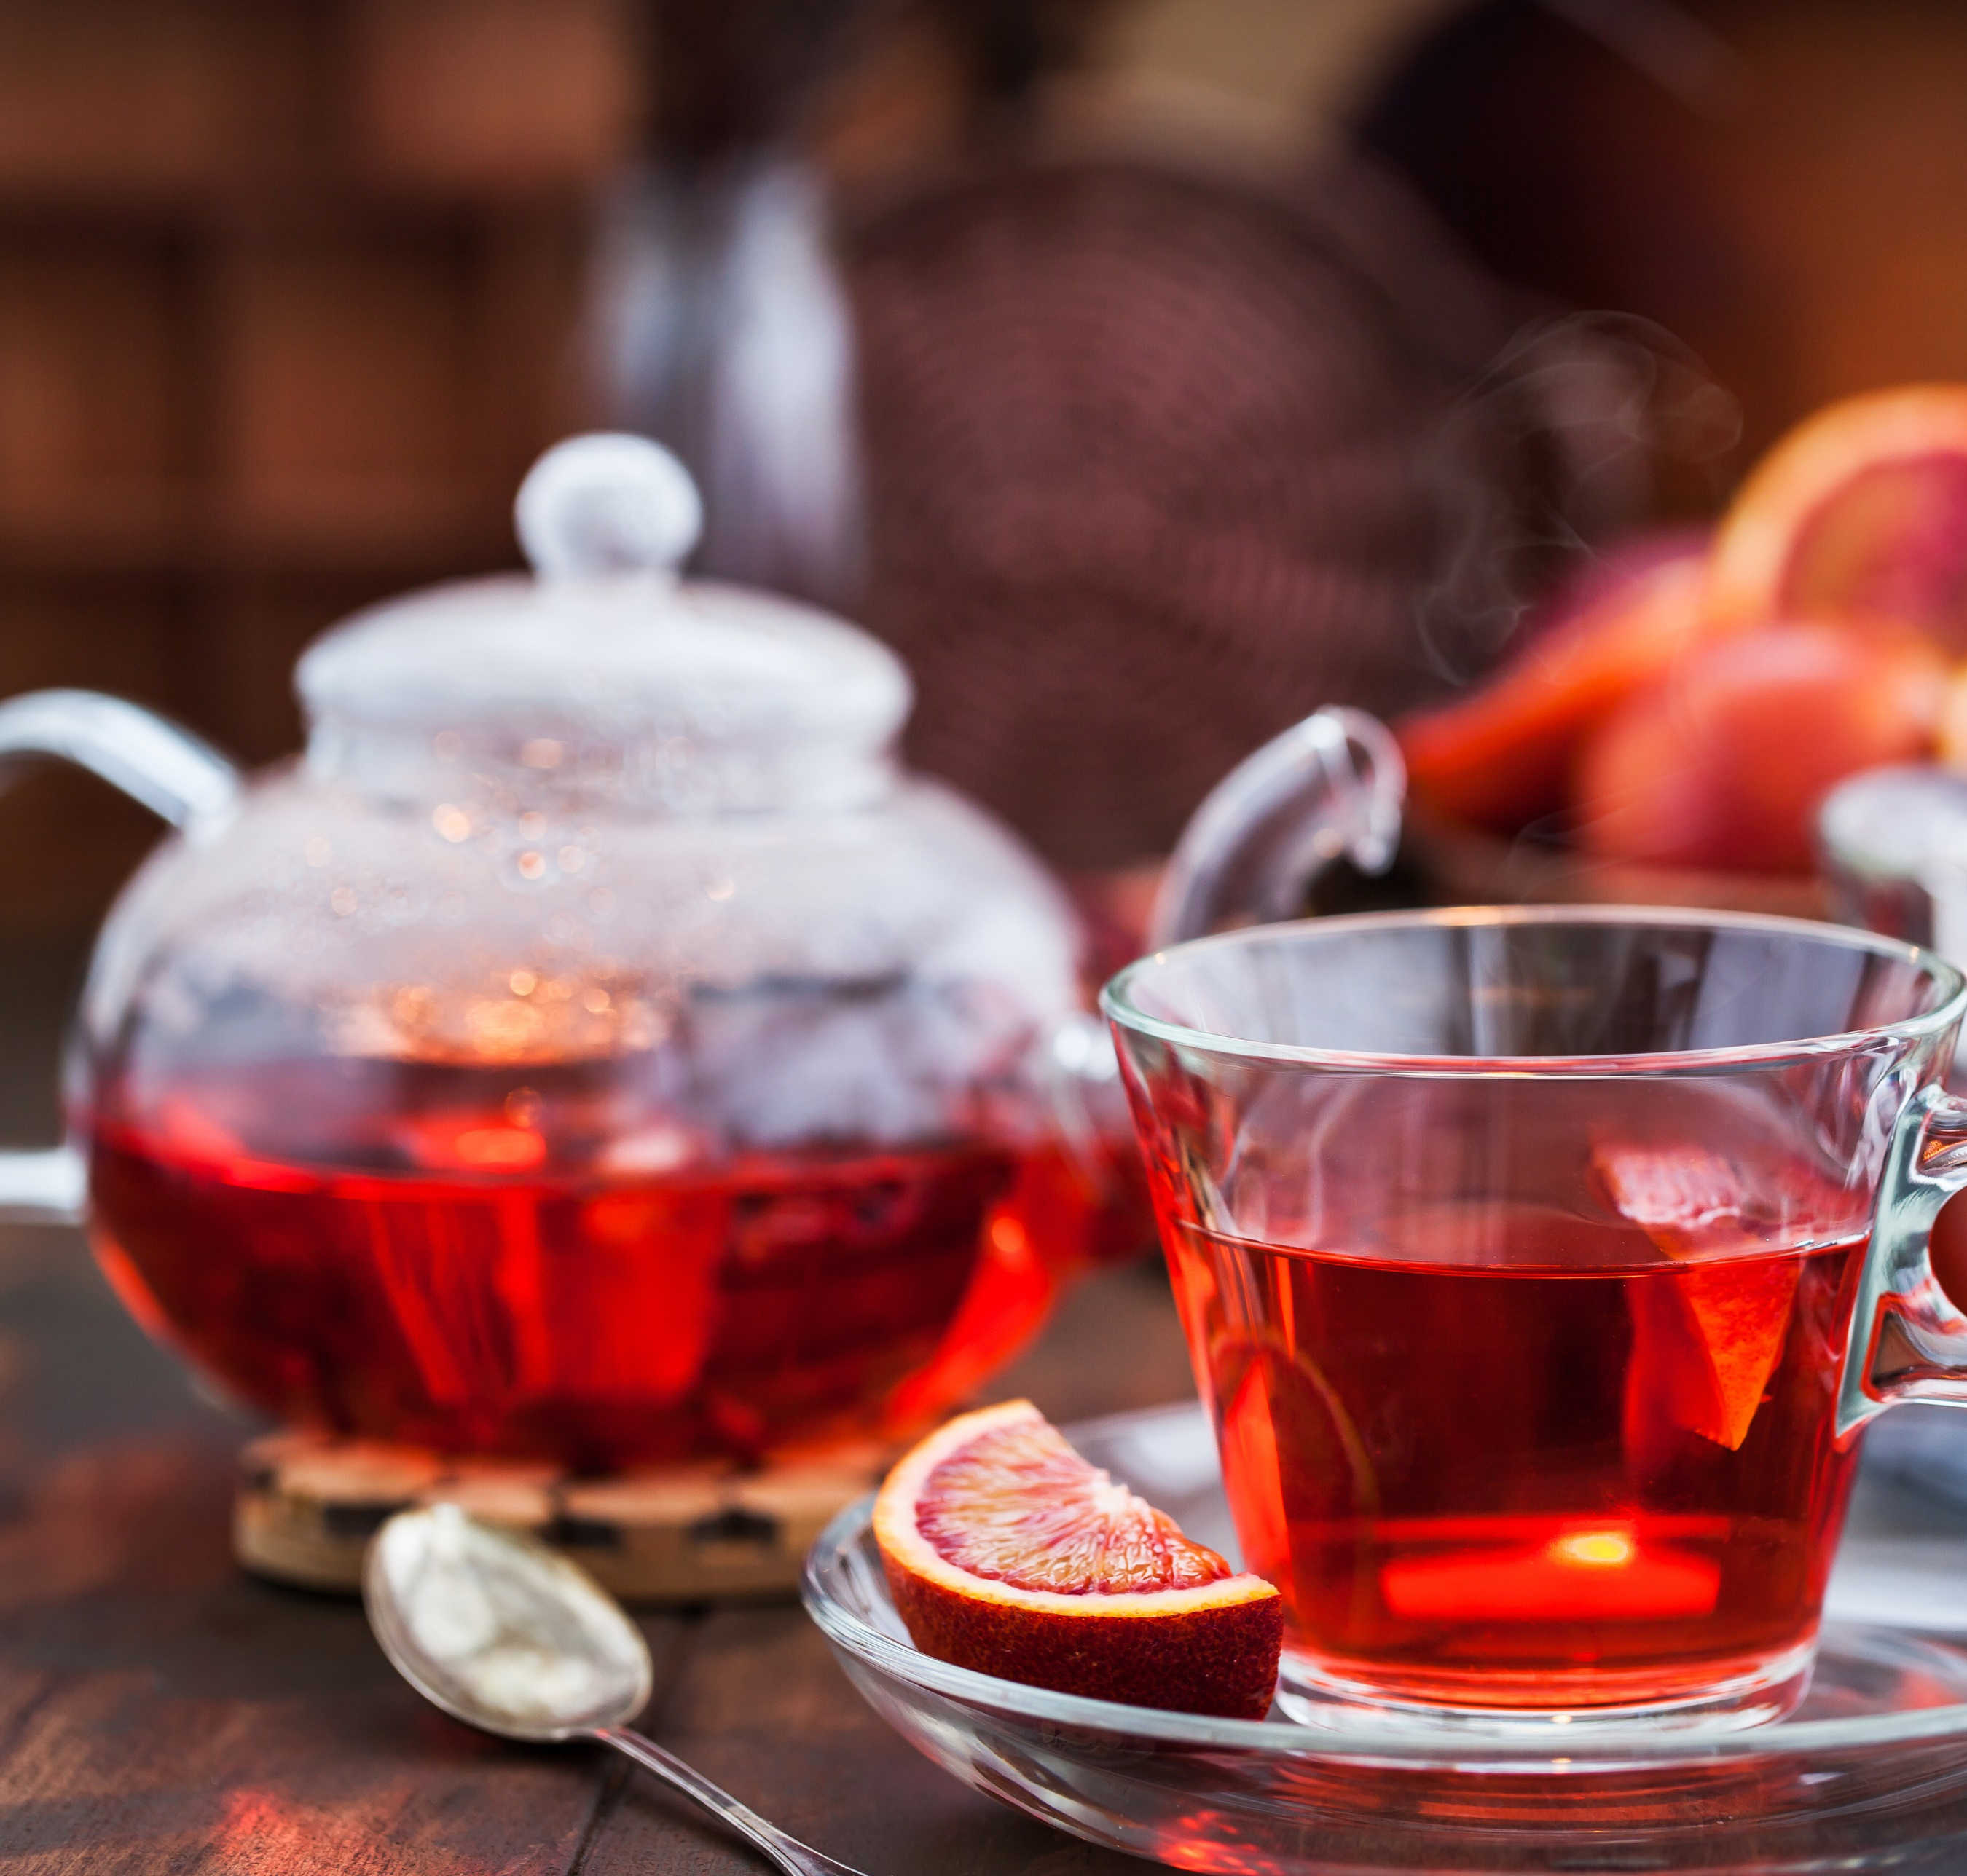
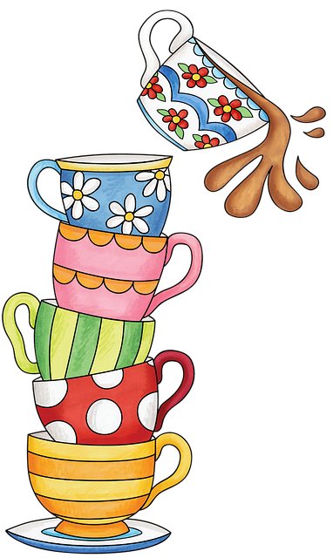

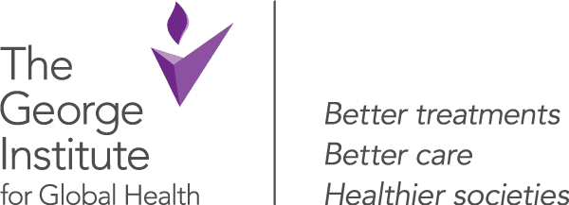
Queensland Paediatric Sepsis Program
Sepsis is a leading cause of harm in children.
This Paediatric Sepsis Week join the Sips for Sepsis morning tea to help raise awareness and remember to ask
#CouldItBeSepsis?
What: Morning tea
When:
Where:
Why: Paediatric Sepsis Week / World Sepsis Day

for
Sips
Sepsis

